**IBM – BIG DATA ANALYSIS [PH-4]**

**Introduction :**

**In this phase we are going to get the data and to advanced analysis techniques and visualizing the results by NLTK Natural Language Toolkit.**

**We will do it by following steps Ahead!**

**Requirements:**

**Ibm Db2,Dataset,Watson Studio, Model to predict**

1. **GO TO Watson Studio Data Pak**

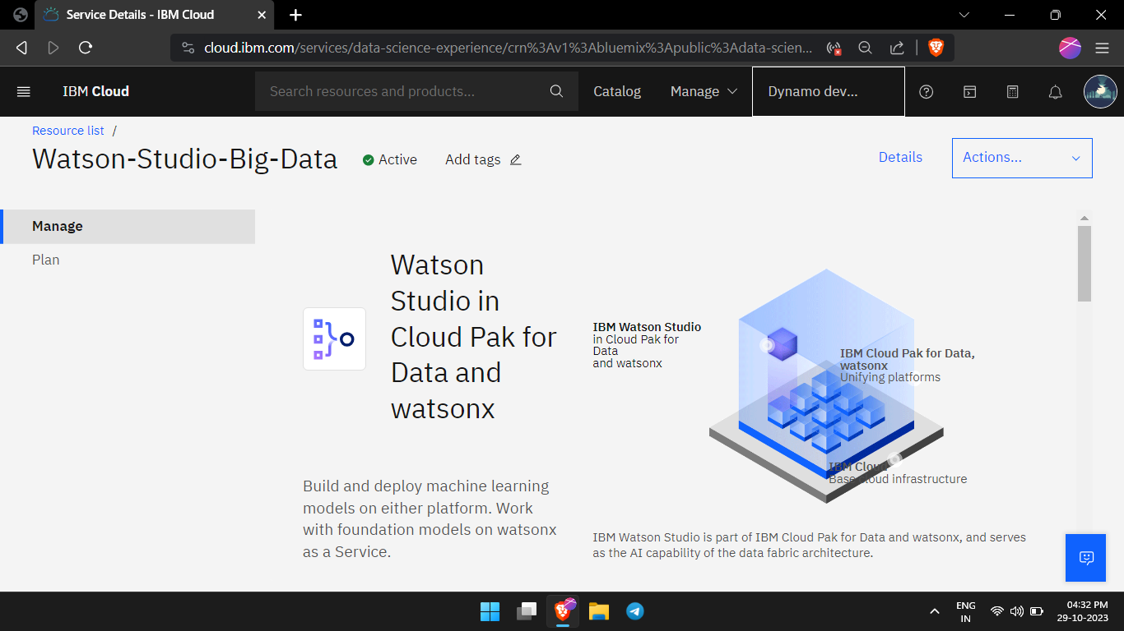

1. **CREATE AN INSTANCE**

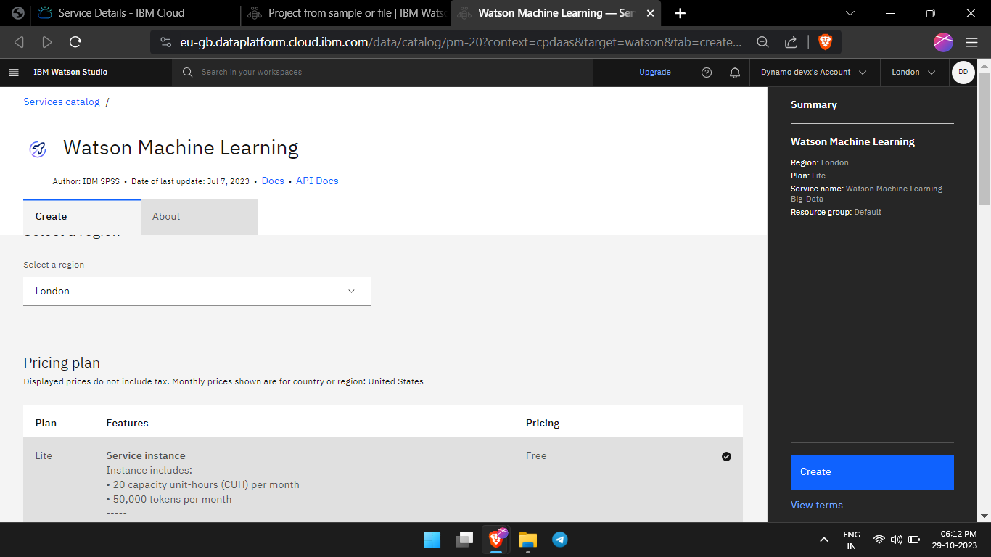

1. **CREATE A CLIMATE PROJECT**

1. **NAVIGATE TO DASHBOARD**

1. **INITIALISE THE vCPU CLOUD MACHINE**

1. **UPLOAD THE DATASET , PMML MODEL , VISULISATION PROGRAM**

1. **GET THE ACCESS KEYS / GENERATE THE PROJECT Token Key / ID and Specify the Urls**

1. **GET THE PREDICTION FOR FORECASTING WEATHER**A screen shot of a computer program

   Description automatically generated

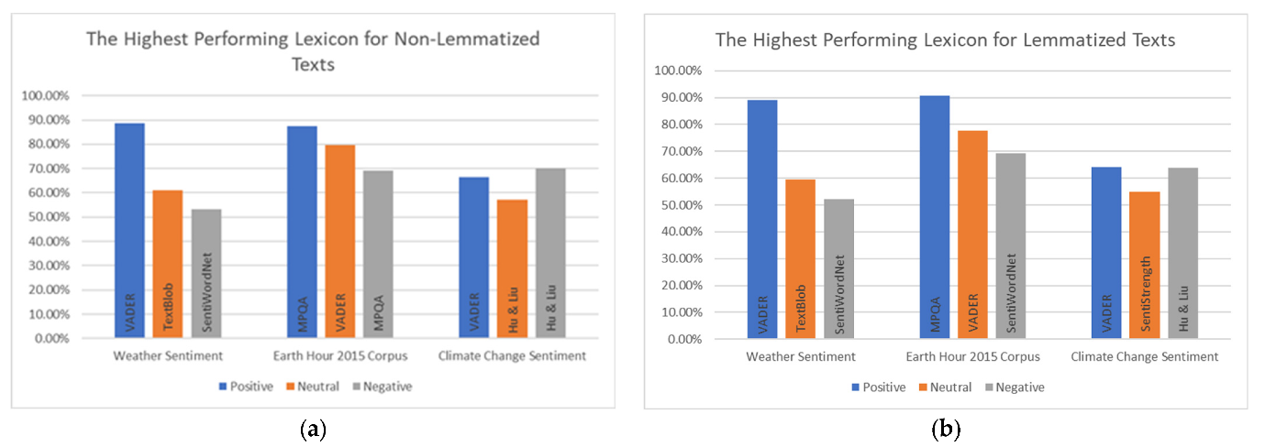

1. **START RUNNING THE CELLS IN JUPYTER-NOTEBOOK**A screenshot of a computer

   Description automatically generated
2. **BY USING THE PANDAS in Python Plot the analysis for visualization**

1. **GRAPH THE VISUALS**

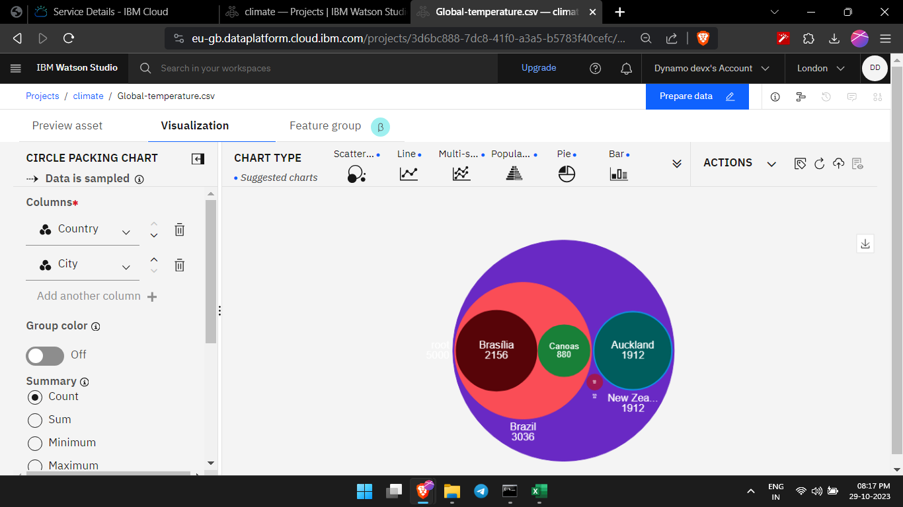

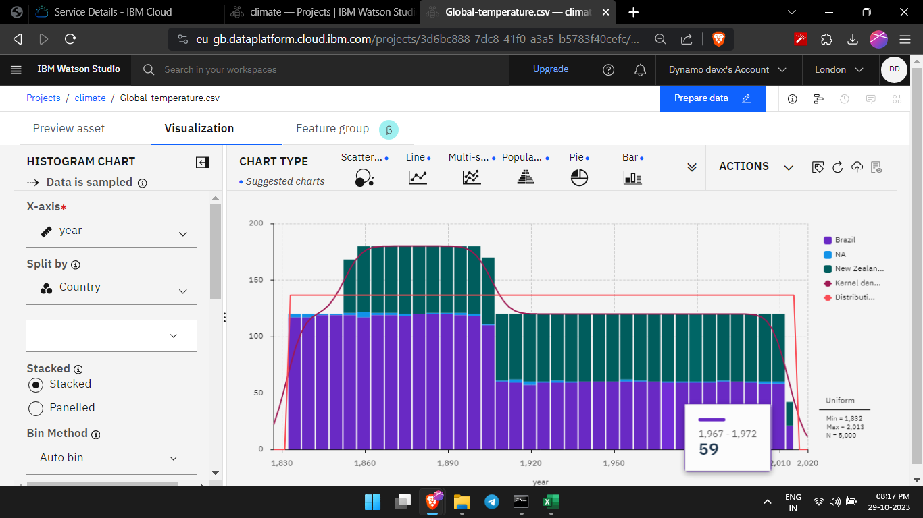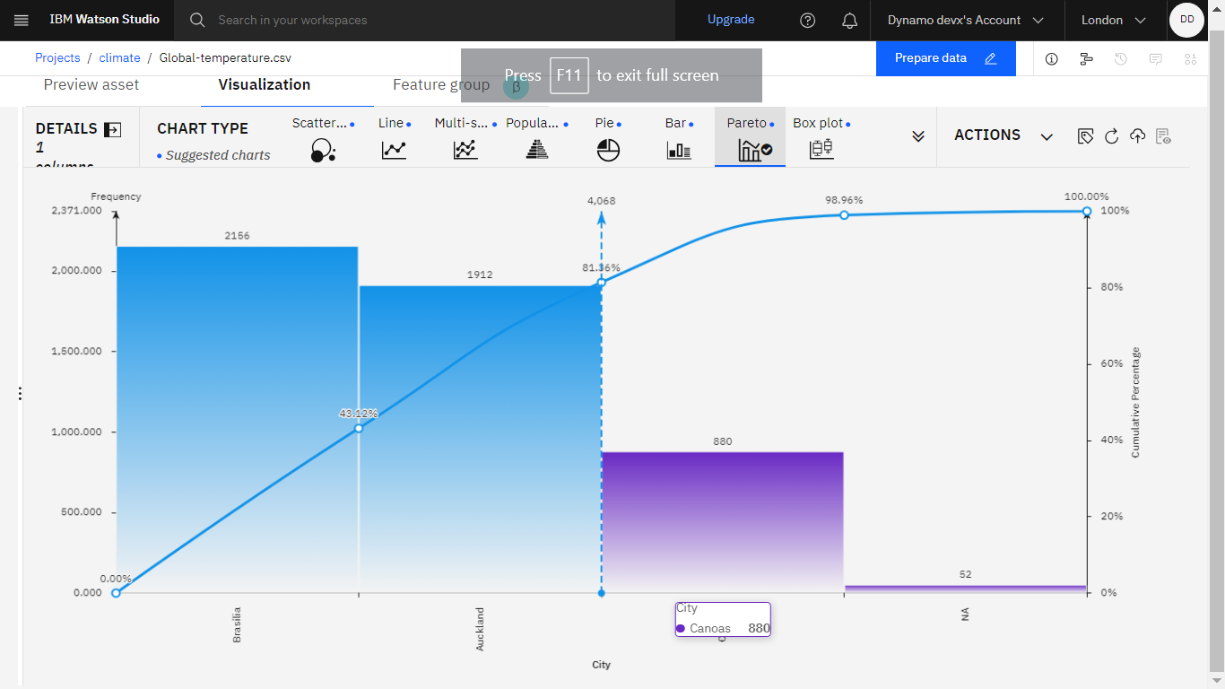

CONCLUSION:

Thus we have , explored about the predictions by using the NLTK – Natural Language Kit , and visualised the different data in our climate changes by using the pandas and matplotlib in python.